**FODS ASSIGNMENT 3 REPORT**

Group Members: -

2017A7PS0186H – Yash Jain

2017A7PS0180H – Siddharth Jain

2017A1PS1100H – Dharesh Vatsa

**Theory:**

Bern (x |μ) = μx(1−μ)1−x

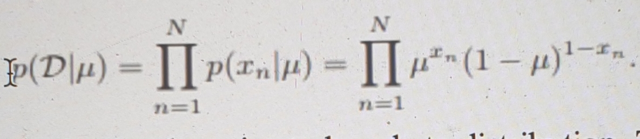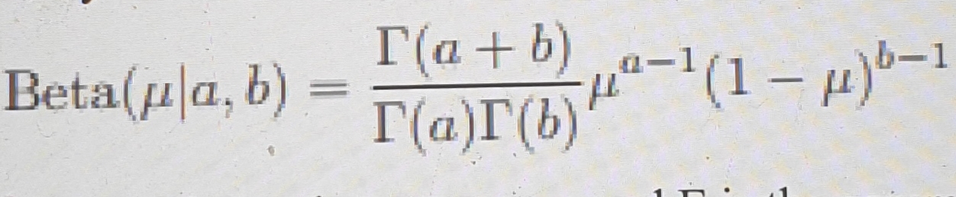

**Plots for part A after an interval of 20 iterations-**

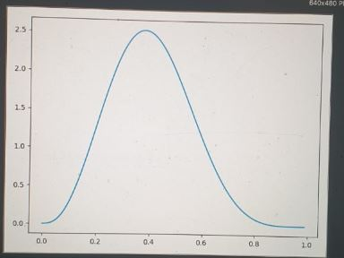

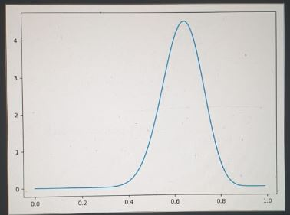

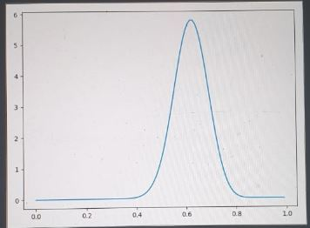

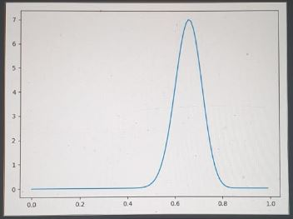

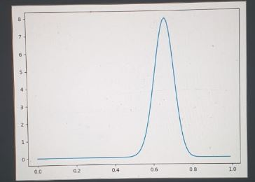

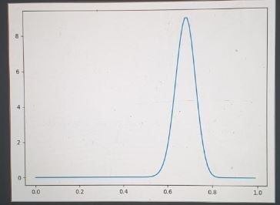

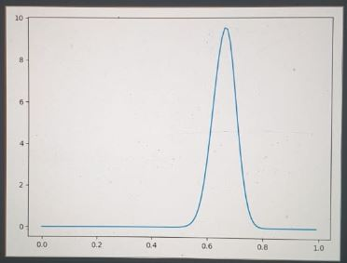

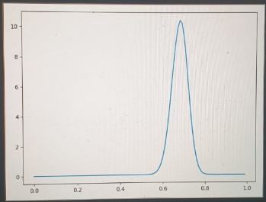

**Final Plot for part B-**

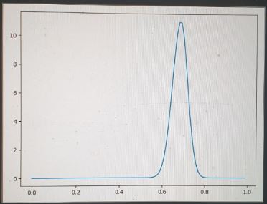

**Comparison between the two models-**

For Part A, we gradually changed the values of a and b according to dataset and plotted them, we found that after every 20 iterations from start we were close to the original value of mean = 0.7.

For Part B, after iterating on the entire dataset we got the closest value to mean = 0.7 and we can see from the plot obtained that for the last graph of Part A and for graph of this part are almost same, which should happen theoretically. Thus, our results are significant.